Cl-3001 - Coputer networks lab

LABORATORY MANUAL ⦁Spring 2023 ⦁Student ID – K-20-1052: S.M.Hassan Ali

|  |
| --- |
| **LAB 04** |
| **Implementation & understanding of HTTP/HTTPS and**  **Network traffic analysis of HTTP/S protocol headers, cookies using Wireshark** |



|  |  |  |  |  |
| --- | --- | --- | --- | --- |
|  | | | | |
|  | | | | |
|  | | | | |
| **S.M.Hassan Ali** | | **K20-1052** | |  |
| ________________________________________ | | __________ | |  |
| STUDENT NAME | | ROLL NO | |  |
|  | | | | |
| ______________________________________ | | | | |
| SIGNATURE & DATE | | | | |
| **MARKS AWARDED: ______________** | | | | |
| ___________________________________________________________________ | | | | |
| **NATIONAL UNIVERSITY OF COMPUTER AND EMERGING SCIENCES (NUCES), KARACHI** | | | | |
| Version: 1.0  Date: 17th **February 2023** | | | | |
| Instructor Name: | **Muhammad Nadeem Ghouri** |  |  | |

**Lab Session 04**

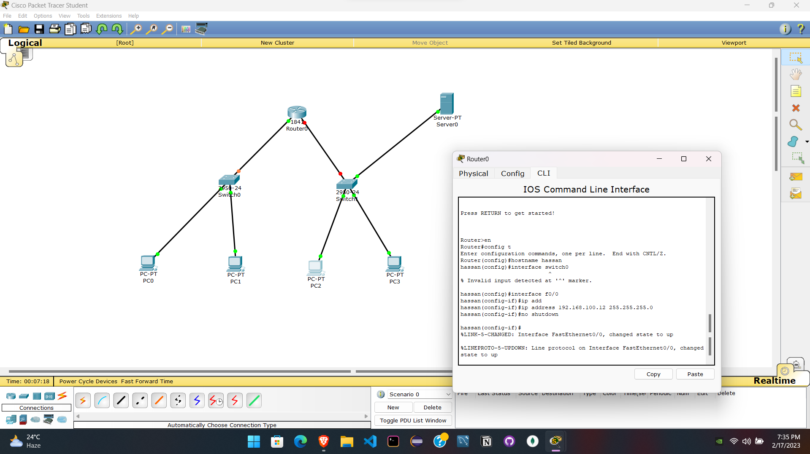

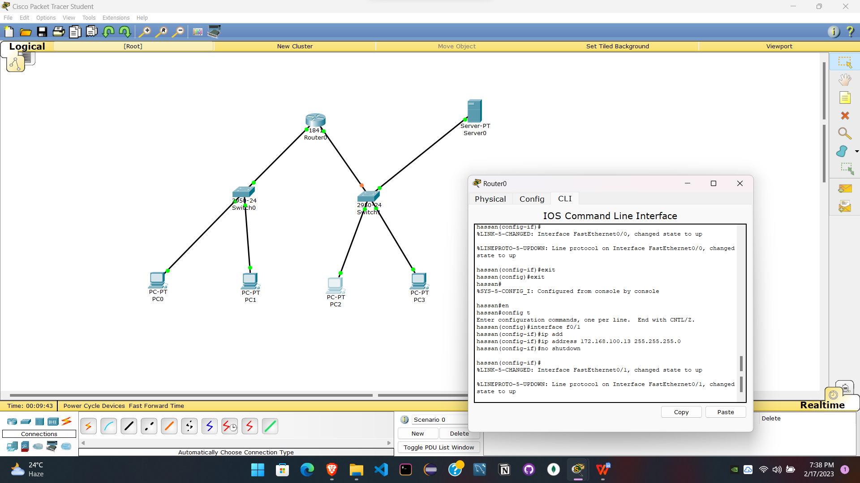

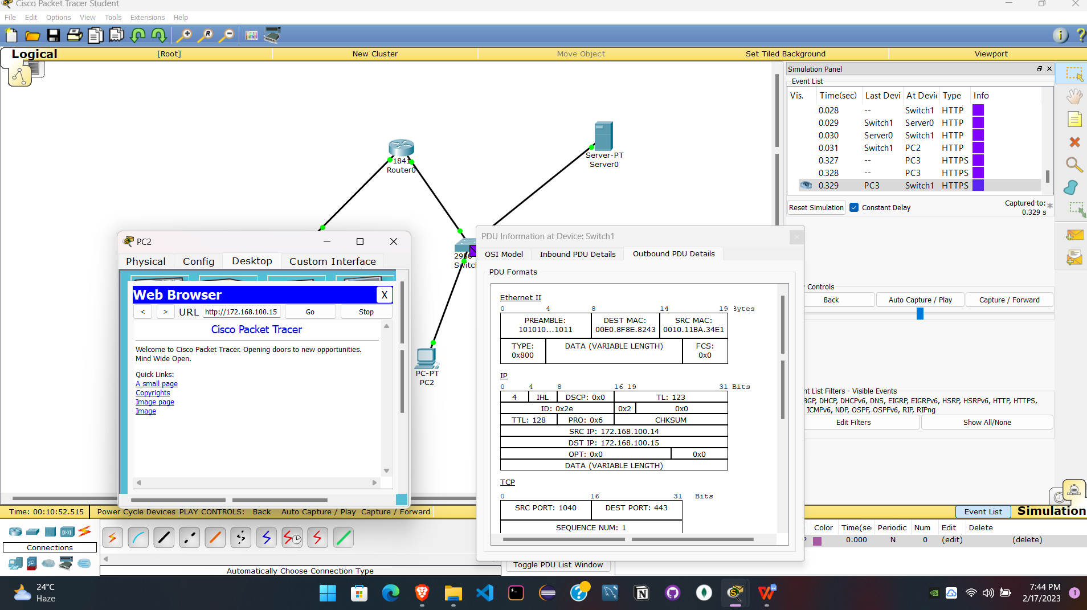

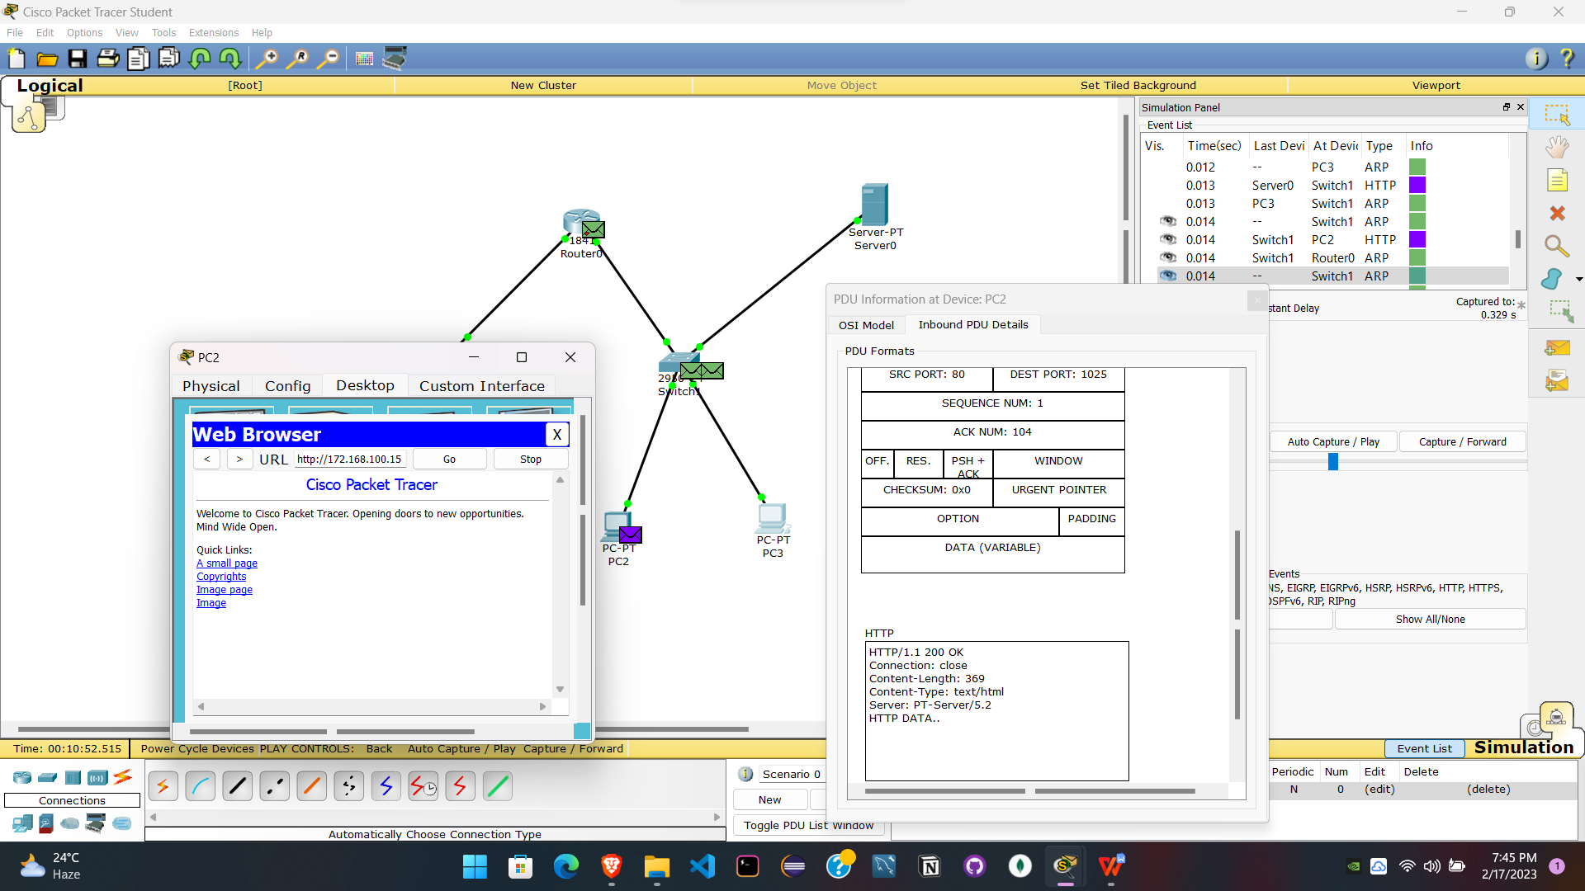

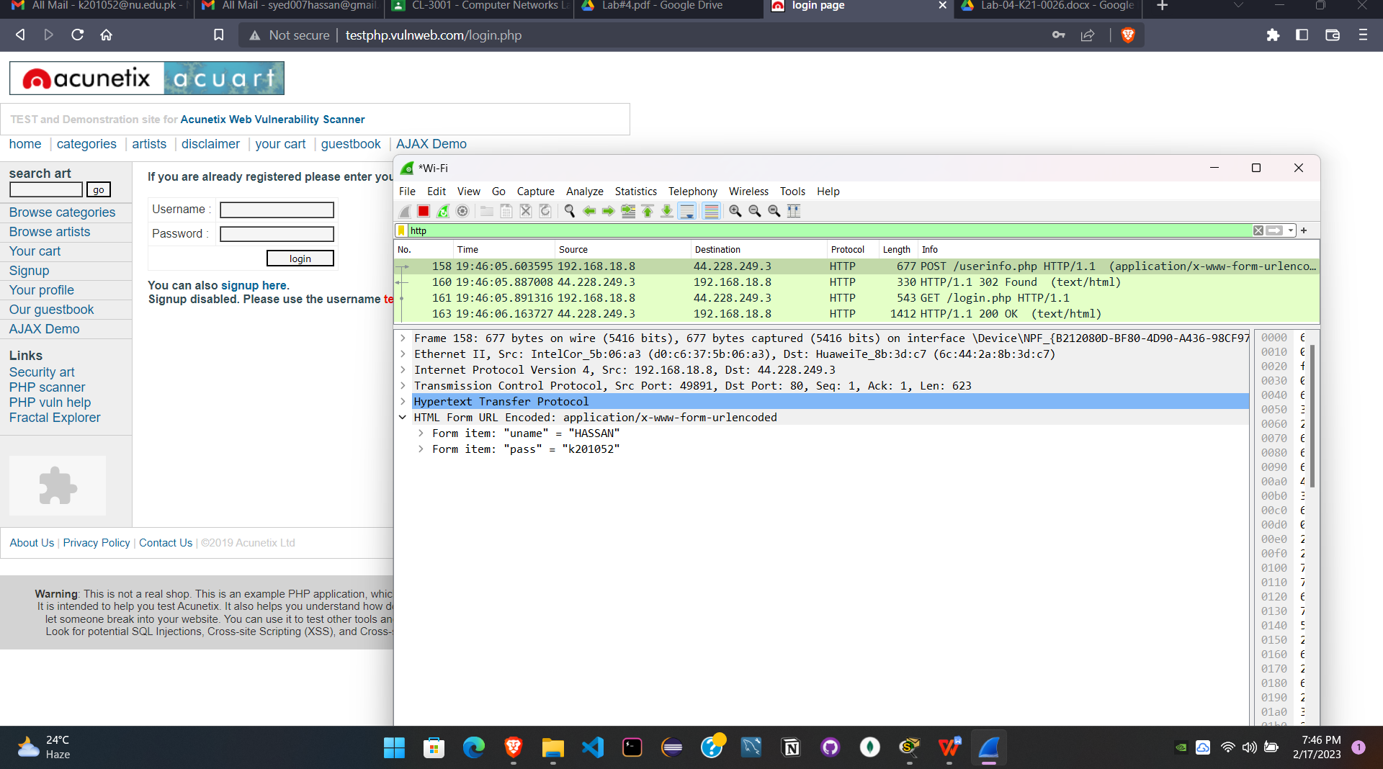

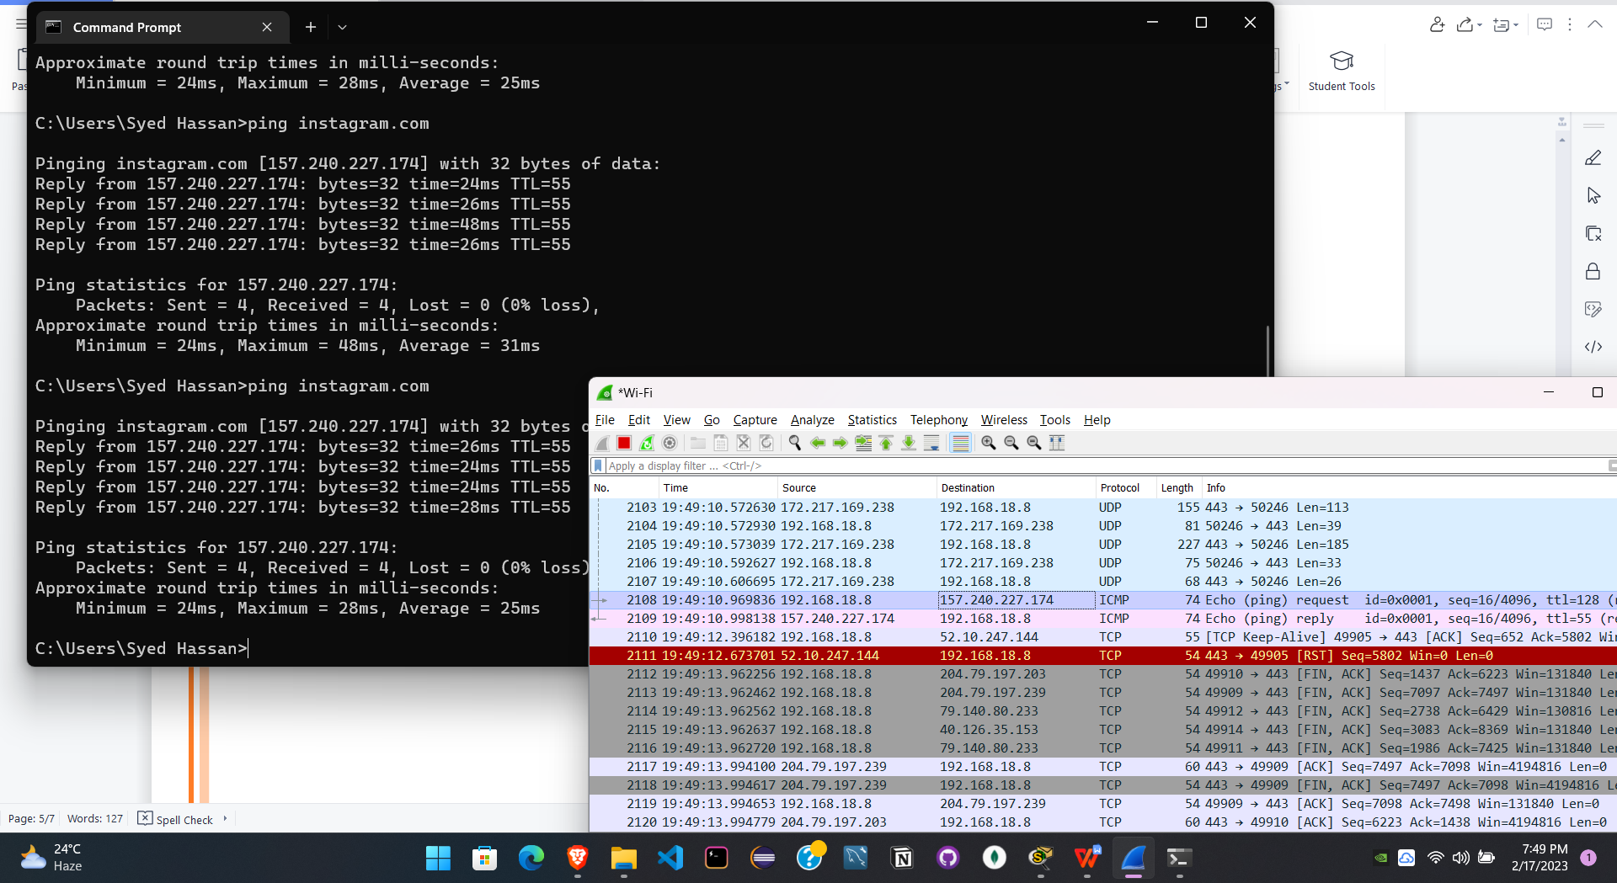

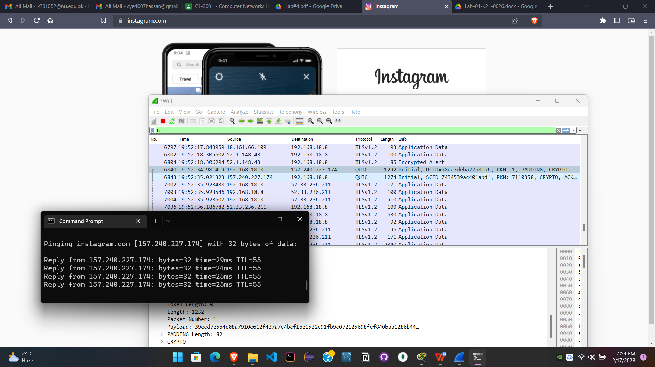

**Comprehensive Report**

In this lab we understand and learned, Implementation of HTTP/HTTPS and learned about Network traffic analysis of HTTP/S protocol headers, cookies using Wireshark. We also learned that how we configure router.

First we connected two switches to a router and then configured it using 2 different gateways one for each. Each of the two pcs have same gateway. Right side connection also had a server that was used to get response in pc when its ip was pinged in terminal. Then we sent a msg and filtered the protocols to see only HTTP and HTTPS. In HTTP we saw that the data was visible in the post method so it was insecure and port was 40 and did not use any encryption to hide the data. While the HTTPS method showed the hashed data that was encrypted and had 403 protocol.

Then we used Wireshark to packets sniffing and to see how the HTTP and HTTPS method shows data in each layer. Entered username and password in a HTTP website that showed the whole data while HTTPS website was filtered using TLS. Then pinged instagram.com to see the TLS protocl ip and the data in transport layer as hashed.